PSG COLLEGE OF TECHNOLOGY, COIMBATORE - 641004

Department of Applied Mathematics and Computational Sciences

Computer Networks and TCP/IP Lab – 18XW46

MSc SS - Semester 4

**Socket Programming – UDP**

**Goal:**

**To Learn the following:**

* What is a socket?
* The client-server model
* Byte order
* UDP socket APIs

1) Write a program to create a Simple UDP server and UDP client. The UDP server must receive an IP address from the client and return the reachability of the IP from the server.

2) Write a program to create a UDP Echo server that can handle multiple clients simultaneously.

Version 1: Using while loop (Figure 1)

Version 2: Using Threads (Figure 2)

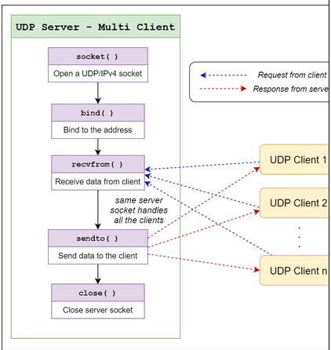

**Figure 1**

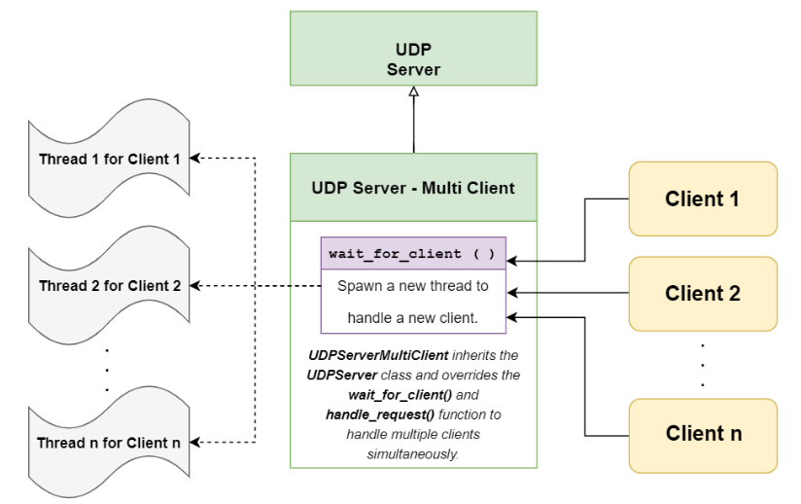

**Figure 2**

**UDP Socket Programming:**

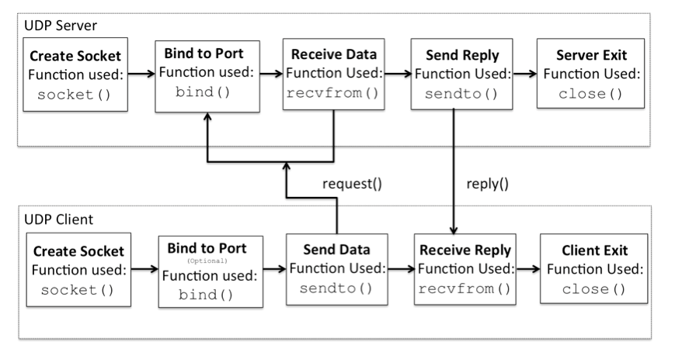

**Sample Code for reference**

## Example: UDP Server using Python

|  |
| --- |
| import socket    localIP     = "127.0.0.1"  localPort   = 20001  bufferSize  = 1024    msgFromServer       = "Hello UDP Client"  bytesToSend         = str.encode(msgFromServer)    # Create a datagram socket  UDPServerSocket = socket.socket(family=socket.AF_INET,  type=socket.SOCK_DGRAM)    # Bind to address and ip  UDPServerSocket.bind((localIP, localPort))    print("UDP server up and listening")    # Listen for incoming datagrams  while(True):      bytesAddressPair = UDPServerSocket.recvfrom(bufferSize)      message = bytesAddressPair[0]      address = bytesAddressPair[1]      clientMsg = "Message from Client:{}".format(message)     clientIP  = "Client IP Address:{}".format(address)          print(clientMsg)     print(clientIP)        # Sending a reply to client      UDPServerSocket.sendto(bytesToSend, address) |

## **Example: UDP Client using Python**

|  |
| --- |
| import socket    msgFromClient       = "Hello UDP Server"  bytesToSend         = str.encode(msgFromClient)  serverAddressPort   = ("127.0.0.1", 20001)  bufferSize          = 1024    # Create a UDP socket at client side  UDPClientSocket = socket.socket(family=socket.AF_INET,  type=socket.SOCK_DGRAM)    # Send to server using created UDP socket  UDPClientSocket.sendto(bytesToSend, serverAddressPort)    msgFromServer = UDPClientSocket.recvfrom(bufferSize)    msg = "Message from Server {}".format(msgFromServer[0])  print(msg) |